Running head: CELL CYCLE
Cell Cycle
Student’s Name
Institutional Affiliation
Cell Cycle
Part 2: Data Tables & Illustrating the Time Spent in Each Cell Cycle Stage
Now that you are familiar with the different stages of the cell cycle, we will use images of garlic roots to estimate the length of time spent in each phase. You will record your data in the provided worksheet.
Complete the table below using the slides contained the virtual lab:
 | Slide  1 | Slide  2 | Total Cells Observed in each Stage: | Time Spent (in minutes) | Percentage of time spent
Total Cell Count: | 288 | 132 | 420 | 720 | 100 %
Prophase Count: | 67 | 36 | 103 | 176.5 | 24 %
Metaphase Count: | 5 | 1 | 6 | 10.3 | 1 %
Anaphase Count: | 10 | 3 | 13 | 22.3 | 3 %
Telophase Count: | 14 | 3 | 17 | 24.1 | 3 %
Interphase Count: | 192 | 89 | 281 | 481.7 | 69 %
- The first two data columns should contain your observations and cell counts from the two slides of garlic roots.
- Complete the “Total Cells Observed” column of the table by adding together the number of cells observed in each stage (first image + second image).
Continue by viewing the images below.
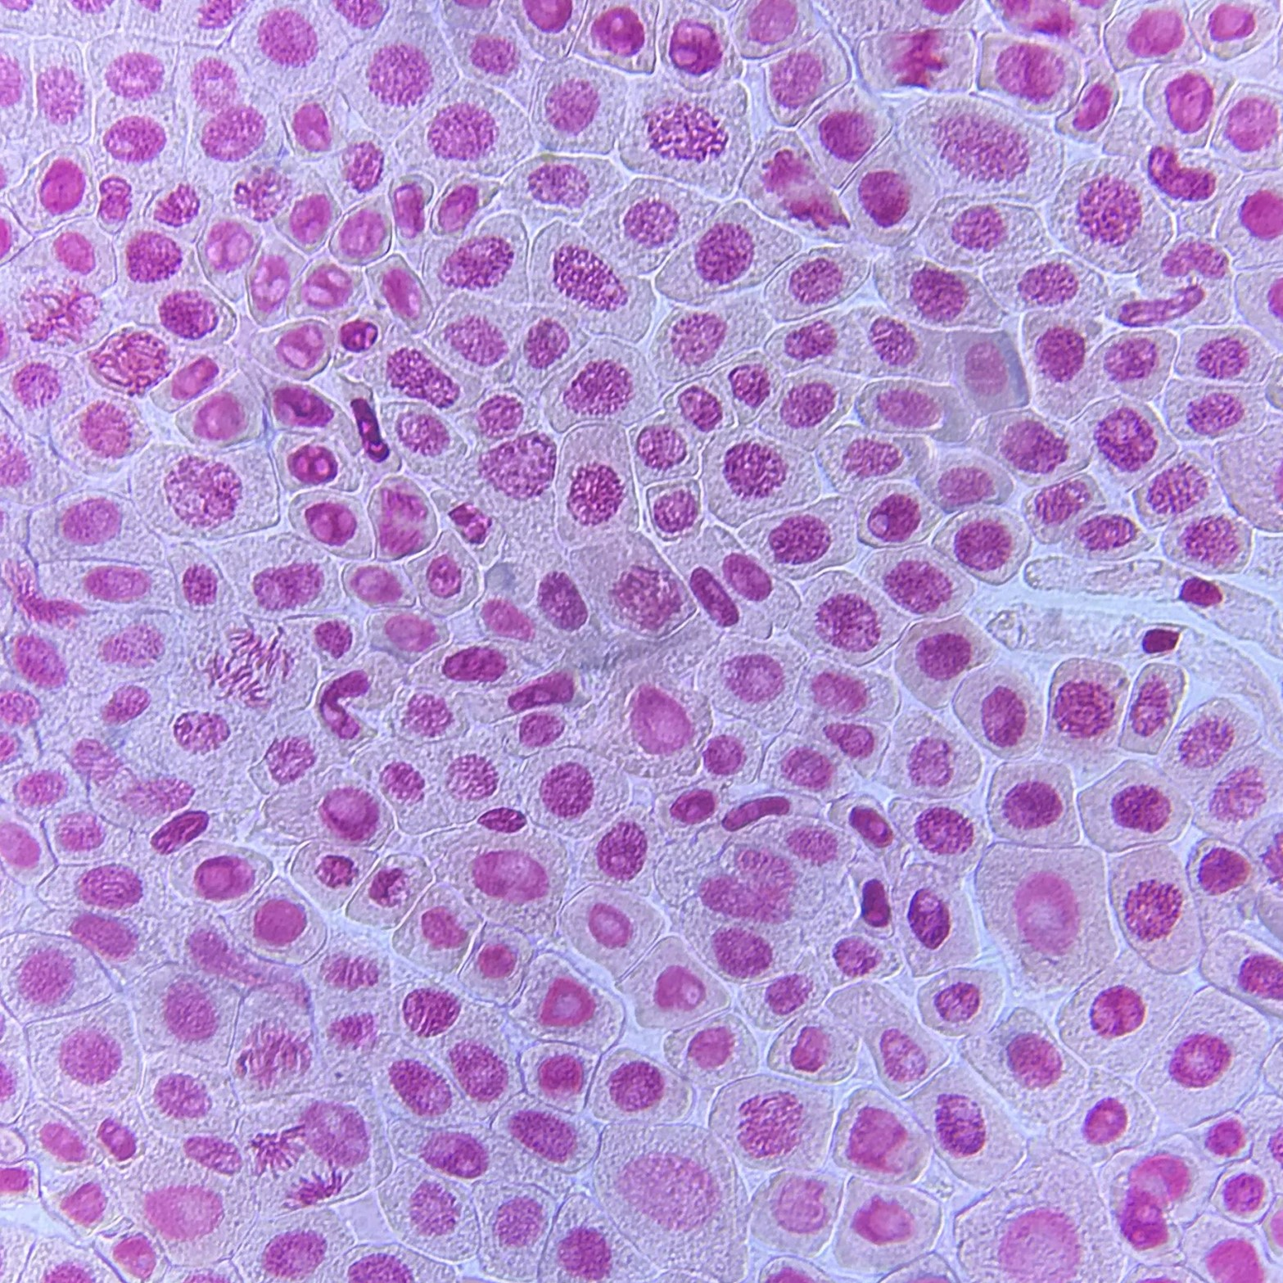
The first step is to estimate the total number of cells within the microscope image. Do this by counting across the top, then down one side and then multiply the two numbers to get at total number of cells in the field of view. These numbers should be recorded in your data table of your worksheet.
Approximately how many cells are in the slide image? 288 cells How many cells appear to clearly be in prophase?
Since chromosomes are condensed at this stage, they can easily be seen under the light microscope. In these slide, 67 cells are clearly observable.
How many cells appear to clearly be in metaphase?
From the slides, only 5 cells have their nuclear membranes disintegrated with the chromosomes attached to the microtubules.
How many cells appear to clearly be in anaphase?
10 cells were observed to have their sister chromatids drawn towards the poles by the shrinking spindle fibres.
How many cells appear to clearly be in telophase?
This stage has the cell separated into two daughter cells since the DNA has uncoiled. 14 cells were observed to be in this stage.
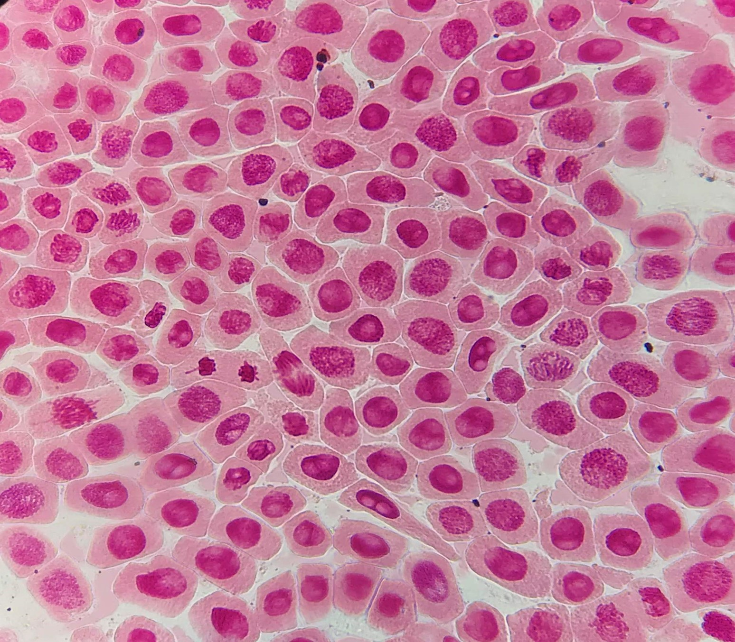
Approximately how many cells are in the slide image? 132 cells
How many cells appear to clearly be in prophase? 36 cells
How many cells appear to clearly be in metaphase? 1 cell
How many cells appear to clearly be in anaphase? 3 cells
How many cells appear to clearly be in telophase? 3 cells
How many cells would be in interphase?
The total number of cells from both slides is 420. Total number of cells from the above 4 stages is 36+1+3+3=43 cells. Thus cells in interface styles will be 132-43=89 cells.
- You can assume that the number of cells in a stage is an indication of the time spent in that stage. Using this information, the time spent in a mitosis stage and in interphase can be calculated if the total time for mitosis is known. Garlic cells require 12 hours (720 minutes) to complete a cell cycle (from interphase to interphase). This information will be used to calculate the time required for each phase of the cell cycle.
Time spent in a stage = (Number of cells observed in the stage/Total number of cells) x 720 minutes.
Time spent in prophase=(103/420)x720=176.5 minutes
Time spent in metaphase=(6/420)x720=10.3 minutes
Time spent in anaphase=(13/420)x720=22.3 minutes
Time spent in telophase=(17/420)x720=24.1 minutes
Time spent in interpahse=(281/420)x720=481.7 minutes
- Now that you know approximately how many minutes were spent in each stage, that information will be used to calculate the percentage of time spent in each stage of the cell cycle. The formula to determine the percentage of time spent in each stage, and complete the last column of the data table:
( Total time spent in stage/total time)*100 = % of time
Percent of Time Spent in prophase=(176.5/720)x100=24%
Percent of Time Spent in metaphase=(10.3/720)x100=1%
Percent of Time Spent in anaphase=(22.3720)x100=3%
Percent of Time Spent in Telophase=(24.2/720)x100=3%
Percent of Time Spent in interphase=(481.7/720)x100=69%
- Use your information from the garlic slides to create a pie chart that illustrates the percentage of time spent in each cell cycle stage.
